SUNYANI WEST MUNICIPAL
2021 NUTRITIONAL REPORT
Introduction
Nutrition is a critical part of health and development. Better nutrition is related to improved infant, child and maternal health, stronger immune systems, safer pregnancy and childbirth, lower risk of non-communicable diseases (such as diabetes and cardiovascular disease), and longevity.
Healthy children learn better. People with adequate nutrition are more productive and can create opportunities to gradually break the cycles of poverty and hunger.
Malnutrition rates remain a concern in the Municipal. There is a high burden of communicable disease alongside increasing NCDs and obesity in adults. The department runs a number of programs amongst which are:

Activities Carried-Out
- Nutrition Friendly School Initiative
- Micronutrient Deficiency Control
- Anaemia Control
- Vitamin A deficiency Control
- Girl Iron Folic Acid Tablet Supplementation (GIFTS)
3. Non Communicable Diseases
4. Food Demonstration
Nutrition Friendly School Initiative (NFSI)
This intervention aims at ensuring adequate nutrition for school age children and is being implemented in collaboration with the Ghana Education Service and the Ghana School Feeding Programme. The main aim of the NFSI is to provide a framework for ensuring integrated school-based programmes which address the double-burden of nutrition-related ill health to become the nutrition module of the Health Promoting Schools.
Picture1: Egg day celebration at Odumase Presby School
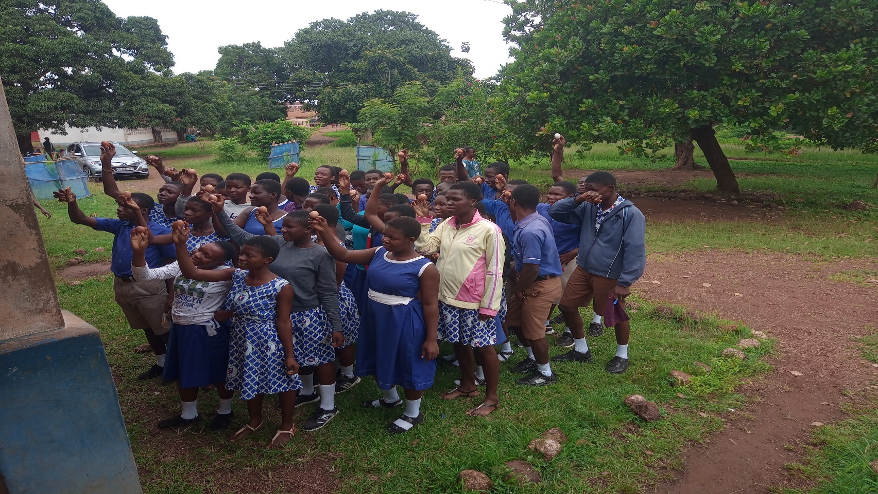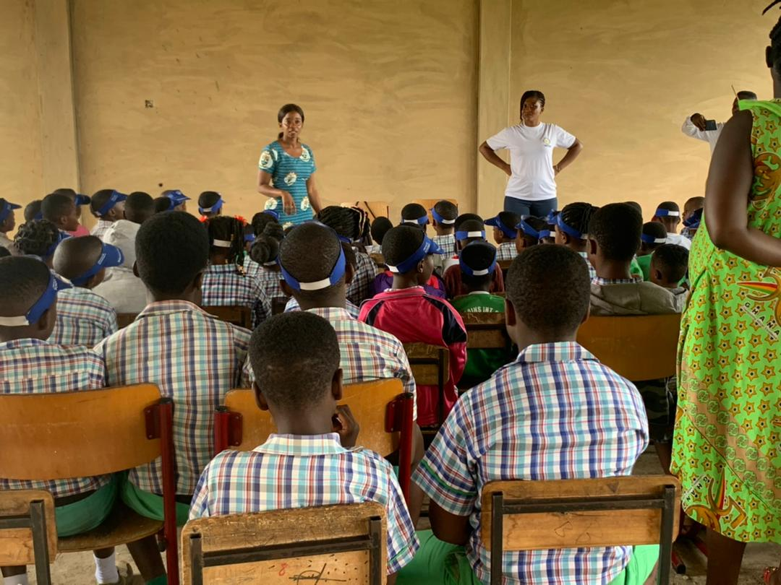
Micronutrient Deficiency Control
The three micronutrient deficiencies of known public health significance are deficiencies due to iron, iodine and vitamin A. A number of intervention strategies are being implemented for their control. This include: the Anaemia control Program, the Vitamin A supplementation Program and the Iodine Deficiency Disorders Control Program. The objective of these interventions is to eliminate or reduce significantly the above listed micronutrients deficiencies through fortification, supplementation and behavioral change communication.
Picture 3: Health talk on replacing sweets with fruits and vegetables at GNAPS week celebration.
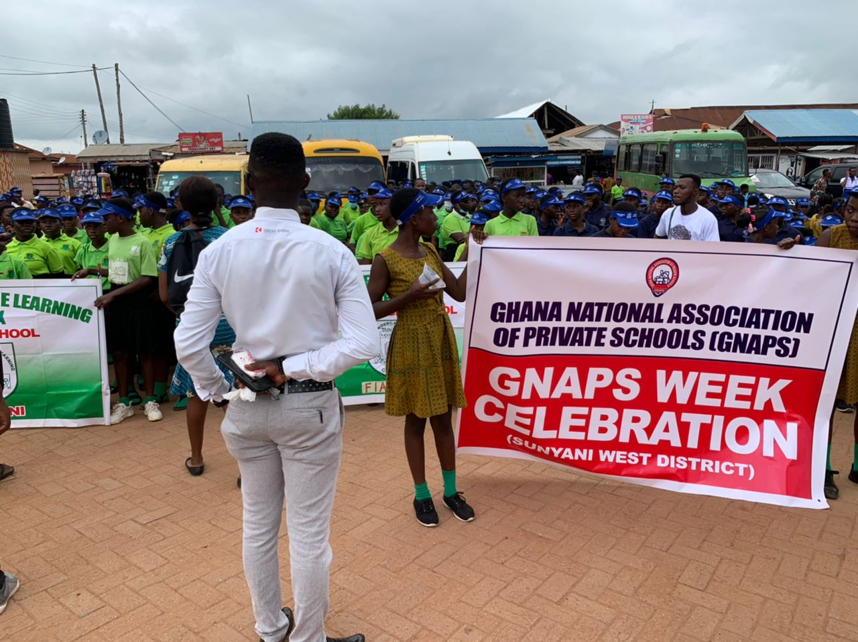

Anaemia Control program
Anaemia is a result of iron deficiency which is the decrease in the amount of red blood cells, which lowers the ability of the blood to carry oxygen. The consequences of anaemia are related to maternal and neonatal deaths, poor intellectual development and low productivity. The anaemia control program aims at reducing iron deficiency among vulnerable groups, this include women of reproductive age, pregnant women and children. Interventions focus on iron-folate supplementation, fortification and BCC to promote the consumption of iron rich foods.
Figure 1: Trend of Anemia 2019-2021

Vitamin A Supplementation (VAS) Program
Vitamin A deficiency (VAD) causes nyctalopia (night blindness) and it is also related to poor pregnancy outcomes and maternal mortality. It also reduces the body’s ability to fight infectious diseases and present a high risk of morbidity among vulnerable groups such as children. The VAS program aims at reducing VAD among vulnerable groups through supplementation and BCC to promote the cultivation and consumption of Vitamin A rich foods.
Performance

Table 1: Vitamin A Supplementation
YEAR | AGE GROUP
YEAR | 6-11 MONTHS | 12-59 MONTHS
2019 | 4,471 | 10,379
2020 | 5,571 | 12,468
2021 | 5,138 | 17,877

2.5.3 Non Communicable Disease
Diabetes and Hypertension was monitored and duly given all the attention it needs to curb the increasing figures. The trend shows a decrease in Diabetes and hypertension as compared to the previous years.
Figure 2: Trend of Non – Communicable Disease

Girls Folic Acid Tablet Supplementation Programme (GIFTS)
The girls’ Iron-Folate table supplementation is a UNICEF sponsored public health intervention designed to provide adolescent girls with weekly Iron and Folic Acid (IFA) tablets free of charge to prevent anaemia. IFA tablet supplements will be provided to in-school adolescent girls and out-of-school adolescent girls aged 10-19 year which started in October, 2017 and taken every Wednesday. Eighty four (84) schools are rolled onto the programme in the district. In 2021, 6231 girls were dosed with IFA tablets.
Food Demonstration
Following training on Infant and Young Child Feeding in 2013, the district decided to embark on a food demonstration at various sub districts during CWC sections to educate mother on the right diet to give to their children in terms of a “four star diet” taking into consideration their Age, Frequency, Amount, Texture, variety, responsiveness and Hygiene using the IYCF approach. This is a significant program to give a practical exhibition of how food is prepared in terms of type, quality and quantity need for child’s growth. The district organized food demonstration in all sub districts.
Challenges
- Inadequate funding to carry out Nutrition activities
- Insufficient training for field staff on child nutrition services
- Inadequate nutrition equipment example Infantometer, stadiometer, hanging scales.
Way forward
- Need for long-term sustainable funding for nutrition intervention
- Plead with Municipal Assembly to support in terms of Funds and equipment

